# **WORKING WITH APACHE IGNITE**

v2.0.0

The aim of this section of the project is to generate a stream of random messages, store it in an Ignite cache and perform SQL queries on these messages.

## Dependencies

* Ignite-core : 2.0.0
* Ignite-spring : 2.0.0
* Ignite-indexing : 2.0.0
* Mysql-connector-java : 5.1.42

## Message Object

A Java class called Message was created with the following attributes and member functions. Objects of this class were used to store data in the Ignite cache. A total of 1 million records were generated using instances of this class. Each object was the value pair to a unique key, which was the Message ID (mid : int). 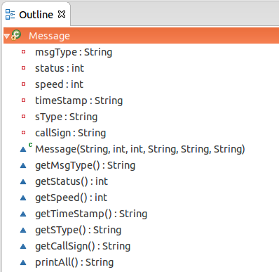

## Queries

1. To pick first 10 messages with message type "Type00".

SELECT * FROM Message WHERE msgType='Type00' LIMIT 10

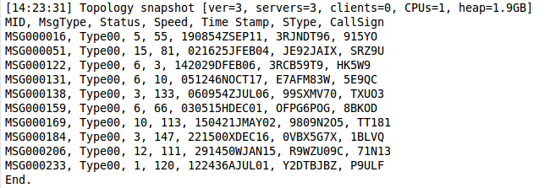

1. To select top 5 fastest messages with status 5.

SELECT * FROM Message WHERE status=5 ORDER BY speed DESC LIMIT 5

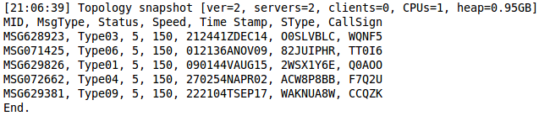

1. To get total number of messages of each type in the year '15.

SELECT msgType, COUNT(timeStamp) FROM Message WHERE timeStamp LIKE '%15' GROUP BY msgType

